**Skeletal Muscle Fiber Preparation**

Note added by Ken. When you tie bundles, timing is important. Try to tie as many bundles as you can in the first 2 hours after you isolate the muscles from the animal. Bundles tied after this time don't seem to be as viable. Plan ahead!

**Things you should do the day before:**

1. Tie loops using sewing thread, make ~60 per muscle
2. Break capillary tubes into thirds, make ~30 per muscle
3. Make sure you have sufficient relax (~250 ml).

**On the day**

**A) Prepare skinning solution**

For each muscle type (soleus, diaphragm, psoas etc) you need a plastic bottle (30 ml size is better than 60 ml size) containing 1% triton solution in relax.

1. To make the skinning solution, add 3 ml 1% triton to 30 ml relax (the easiest way is to pipette 3 ml triton an add it to 30 ml relax in a measuring cylinder).
2. Transfer the skinning solution to the plastic bottle and store on ice.

**B) Prepare storage solution**

For each muscle type (soleus, diaphragm, psoas etc.) you also need a plastic bottle (again, 30 ml size is best) containing glycerol relax solution. (This solution is relax ingredients made up with 50% water / 50% glycerol. It is normally stored in the small freezer in the mechanics lab).

1. Remove the stock glycerol relax bottle from the freezer and place on table.
2. Wait 10 minutes so that the glycerol relax is 'nearer room temperature'.
3. Pour ~30 ml (exact amount is not important) into plastic bottle.
4. Put stock back in freezer.
5. Store glycerol relax on ice.

**C) Harvesting muscles from the animal:**

Materials-

              Sterile pads

              Dissecting tools

              Hypodermic needle

              Sodium pentabarbitol

              ~250ml relax solution

              10% triton vial

              Glycerol

              Ice buckets (with ice)

1.    Collect dissecting tools and lay sterile pads for dissection

2.    Obtain rat and bring to lab

3.    Pour ~100ml relax into a 200ml beaker and 50ml into a second beaker and place both on ice.

4.    Place rat in chemical coma using __ml sodium pentabarbitol injection

5.    Lay rat on sterile pad on its back.

6.    Lift abdominal skin away from organs and make a small cut using scissors.

7.    Continue cut up along each side of the abdomen to the rib cage, being careful not to cut any organs.

8.    Cut through the ribs and rejoin the parallel cuts above the rib cage.  Remove the center of the ribcage and abdominal skin.

9.  Remove heart (and diaphragm if needed for other purposes)

**10.**  **Remove psoas muscles.**

1. Roll rat on its side and gently pull organs from abdominal cavity.
2. Return the rat to its back and locate psoas muscles along either side of the spine.  Pour a small amount of Relax from the small beak onto the muscles
3. Starting from the spine, carefully work forceps under a psoas muscle then slide along length of muscle to separate it from connective tissue.
4. Place forceps around muscle near one end to prepare to clamp
5. Position scissors to cut then quickly clamp muscle and cut one end.  Lift and quickly cut the other end of the muscle.
6. Immediately place the muscle into the 100ml Relax on ice.
7. Repeat process for remaining psoas muscle.

11.   **Remove soleus muscles.**

1. With rat on its back hold a hind leg by the paw a cut skin around ankle.
2. Cut skin up front of leg to hip and peel skin from ankle to hip
3. Carefully cut casing around the lower leg muscles and pour in a small amount of Relax from the small beaker.
4. Work forceps under the Achilles tendon then hold and sever the tendon.
5. Lift the tendon back peeling both the gastrocnemius and soleus muscles.  Pull until the top tendon of the soleus shows at the knee (silver color).
6. Cut the soleus tendon as close to knee as possible then hold the end of the tendon just cut and peel the soleus out from under the gastrocnemius
7. The two muscles should be now connected end to end.  Cut the tendon as close to the gastrocnemius as possible and immediately place the soleus in the 100ml Relax on ice.
8. Repeat for remaining hind leg.

**Tying Bundles:**

**Time is important here. You should try to tie as many bundles as you can in about 2 hours and then skin them for another 4 hours. Bundles tied >2 hours after the muscles are removed from the animal don't seem to be as viable.**

Materials-

              Muscles previously extracted

              Prepared thread loops and capillary tubes

              Glass petri dish (for psoas)

              Glass petri dish with gel bottom (for soleus)

              Fine forceps and scissors

              Rest of .5L Relax solution

              30ml triton and 30ml relax+glycerol solutions previously made Rectangular ice bucket (with ice)

For psoas fiber bundles:

1.    Place ice bucket under dissection scope with black background pressed into ice

2.    Place glass petri dish on black background and fill with Relax

3.    Insert the bottle containing skinning triton solution into same ice bucket

4.    Transfer the psoas muscle fiber into the petri dish of relax.  Make sure that the muscle is completely submerged.

5.    Using forceps, carefully peel muscle into 2 pieces.  Continue splitting fibers until the resultant bundle is approximately the width of the forceps tip.  Make sure to hold the fibers only by the very ends.

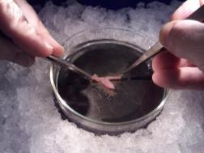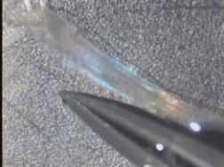

[Larger image](http://docs.google.com/leaf?id=0B65C7lNjU85PMWE2NTY0NzktOGU3NS00MGUyLTlhMTYtY2E1YjA0ZGViZGU1&hl=en)     [Larger image](http://docs.google.com/leaf?id=0B65C7lNjU85PM2IzYWRhYjItYTQ4ZC00Mjg0LWE1NGItMzQzZDA0MDRiZjY2&hl=en)

6.    Now place a capillary tube into the petri dish with the muscle and slide two thread loops on.

7.    Carefully slide one end of the fiber bundle selected through a loop and tighten

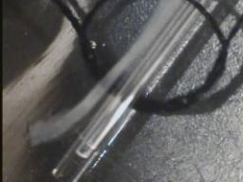

8.    Slide the other end of the bundle through the second loop and tighten.

9.    Pull the loops away from each other until the bundle is held snuggly against the capillary tube.

10.  Recheck that the loops are cinched tight and place tied bundle into the bottle of 1% triton solution.

11.  Repeat process for about 30 bundles.

12.  After all bundles are made, wait 4 hours then transfer all of the tied bundles into the bottle containing ~30ml relax+glycerol and place in freezer.

For soleus fiber bundles:

1.    Place ice bucket under dissection scope with black background pressed into ice

2.    Place glass petri dish with gel bottom on black background and fill with Relax

3.    Insert the bottle containing 30ml 1% triton solution into same ice bucket

4.    Transfer the soleus muscle fiber into the petri dish of relax.  Make sure that the muscle is completely submerged.

5.    Now pin the muscle down by placing 27ga needles into the corners of tendon still connected.

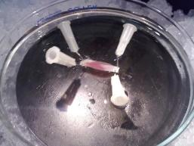

[Larger image](http://docs.google.com/leaf?id=0B65C7lNjU85PZDFiNjgyNmItNDYwNy00NGIyLTg5ZDQtM2IyNTU4Njg0NGMy&hl=en)

6.    Try to clean up the muscle by removing fat and extra connective tissues still remaining.

7.    Near one end of the muscle, make a cut towards the center of the muscle.  Do not cut the tendon.



[Larger image](http://docs.google.com/leaf?id=0B65C7lNjU85PYzZmZjBjZWEtMjFiNi00YzM1LWI4NmEtMjc1NmY3NmQxOTg5&hl=en)

8.    From that cut make a second cut 3-5mm down the center of the muscle.

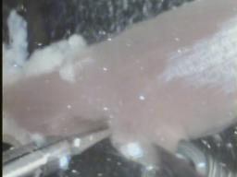

[Larger image](http://docs.google.com/leaf?id=0B65C7lNjU85PYzAwZDcxYzAtMTRlZi00MmFmLWE1ZDItYTk4YWEzMjJiMTUy&hl=en)

9.    Start carefully teasing apart bundles.  Once you get one clear, cut from the main muscle and follow the same tying technique as described in the psoas bundle process.

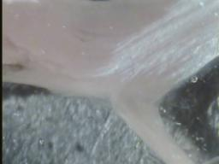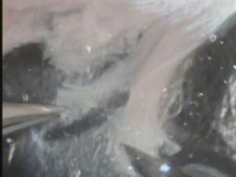

[Larger image](http://docs.google.com/leaf?id=0B65C7lNjU85PODc1MmFiYjYtOGFhNi00MmZlLTg4MzktYTBiODEzODBiMmVh&hl=en)   [Large image](http://docs.google.com/leaf?id=0B65C7lNjU85PMjkxOTdjODYtNTJiNS00MjUxLThlOGEtNGQ0Mzk2YTZmNjU2&hl=en)

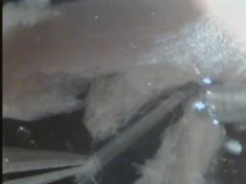(final size)

    Larger image